1.46: a)

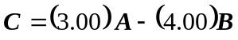
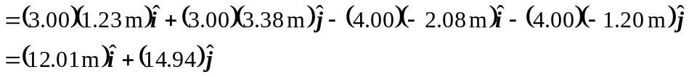
(Note that in adding components, the fourth figure becomes significant.)
- From Equations (1.8) and (1.9),
